Principal: Lindsey Burgin BA (Hons), PGCE, MA
CEO: Rebecca Scutt BSc (Hons), PGCE

January 2026
Dear Parents/Carers,
At Shirebrook Academy, we are committed to making our transition process as smooth as possible for all our children. We are pleased to offer an enhanced transition programme specifically designed for our SEND children. This initiative includes five afternoons where students can visit the Academy, engage with key topics that Year 6 children may find concerning, and receive support with their orientation of our site while meeting important staff members.
During these afternoons, children will have the opportunity to participate in activities that address common worries and help them acclimatise to their new environment. We kindly ask that primary schools assist in facilitating attendance by ensuring that children are transported to and from the Academy and that at least one member of the primary team stay on site for the afternoon. The dates for our enhanced transition programme are listed below, and children are welcome to attend all sessions or just those that you feel would be most beneficial.

Date | Activity
4th June 1.30-2.30pm | ‘Finding my way’ – This session is aimed at the key worries around how children will get to school. How they will get around the site. We will share worries together and have some fun orienteering around our site.
11th June 1.30-2.30pm | ‘My worries’ – This session is aimed at alleviating any worries children might have around secondary school and sharing strategies to help with anxiety.
18th June 1.30-2.30pm | ‘Secondary ready’ – This session aims to show what are the expectations of children at our school, what this looks like and support children if they are worried around uniform etc.
25th June 1.30-2.30pm | ‘We are resilient’ – this session is focused on becoming independent and resilient learners, so children are secondary ready.
29th June 1.30-2.30pm | ‘Friendships’ – this session is aimed at the skills to make good friendship choices and support making new friends in the session.

Please use the QR Code below to book places for your pupils.
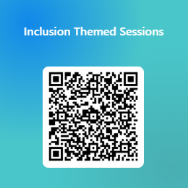
We understand that transitioning to a new school can be a significant change for children and their families. Our aim is to provide a supportive and reassuring experience that fosters confidence and readiness for the next stage of their education. Should you have any questions or require further information about the programme, please do not hesitate to reach out, our email is inclusionteam@shirebrookacademy.org
We look forward to your support in this important transition period and encourage you to discuss this opportunity with your child. Thank you for your cooperation and commitment to ensuring a positive experience for all our students.
Yours sincerely,
Mrs Dunphy
Associate Inclusion Lead
Shirebrook Academy

