

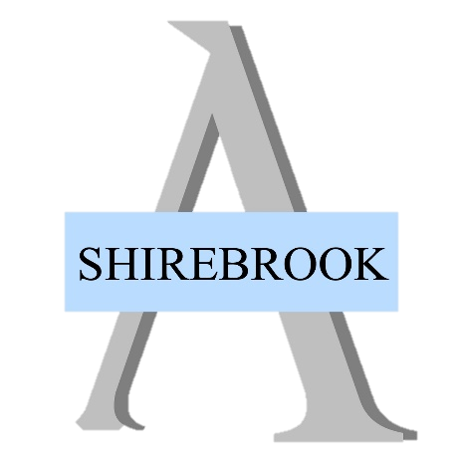
How to apply?
To be supported to make an application, please contact Paul Davies (Early Help Worker) on
07976 880087

To apply within Shirebrook Academy, you must:
- Live in Derbyshire.
- Have a child on roll at Shirebrook Academy.
- Be experiencing financial hardship and be able to provide proof of this.

The Household Support Fund
Can provide short-term urgent financial help to Derbyshire residents who are struggling to afford their household bills.

Need help with buying food, paying for energy and water bills and other household items such as beds and white goods?

Support is available…

Are you struggling with your household bills?

